**ICT171 Assignment 2 – Cloud Server Project & Documentation**

Student Name: J.M. Dilmika Thathsarana

Student Number: 35485605

Date: 2025-06-08

Project Title : Real Estate Website

Website URL : <https://djrealestate.online>

Global IP : 170.64.231.247

Project Overview   
  
The design, implementation, and documentation of a cloud-based server that houses a WordPress website for a made-up real estate company are the tasks involved in this project. The server is protected with SSL/TLS encryption, hosted on DigitalOcean, and set up with Infrastructure as a Service (IaaS). This project aims to show off practical expertise in web application deployment, DNS setup, backup scripting, and Linux server administration in a cloud setting.

🔧 Technology Stack

* **Cloud Provider**: DigitalOcean
* **Operating System**: Ubuntu 22.04 LTS (64-bit)
* **Web Server**: Apache2
* **Database**: MySQL
* **Scripting Language**: Bash
* **CMS**: WordPress (manual installation)
* **Security**: SSL/TLS with Let’s Encrypt
* **Version Control**: GitHub

Infrastructure as a Service(Iaas)

A type of cloud computing known as Infrastructure as a Service (IaaS) offers virtualised computer infrastructure, such as servers, networking, storage, and operating systems, via the internet. IaaS allows users to maintain complete control over the server environment while the provider takes care of the physical hardware underneath.

DigitalOcean served as the IaaS provider for this project. SSH was used to manually provision and access a virtual machine (Droplet). The student showed complete control of the infrastructure configuration by installing and configuring all necessary software components, including Apache, PHP, MySQL, and WordPress.

Intended Audience

This documentation is meant for students, instructors, and ICT personnel who might want to duplicate the server configuration for educational or real-world deployment purposes. The instructions and structure are written in a straightforward, copy-paste-friendly manner, according to technical documentation best practices. In the event that a complete server rebuild is required, it also acts as a disaster recovery reference.

**Server Access Info**

🡪 Global IP Address**: 170.64.231.247

🡪 Domain Name**: <http://djrealestate.online> <https://www.djrealestate.online>

🡪 Platform**: DigitalOcean (IaaS)

🡪 Operating System**: Ubuntu 22.04 (64-bit)

**Step-by-Step Server Setup**

1. Create Droplet

🡪 Platform: DigitalOcean

🡪 OS: Ubuntu 22.04

🡪 Size: Basic (1GB RAM)

🡪 SSH enabled

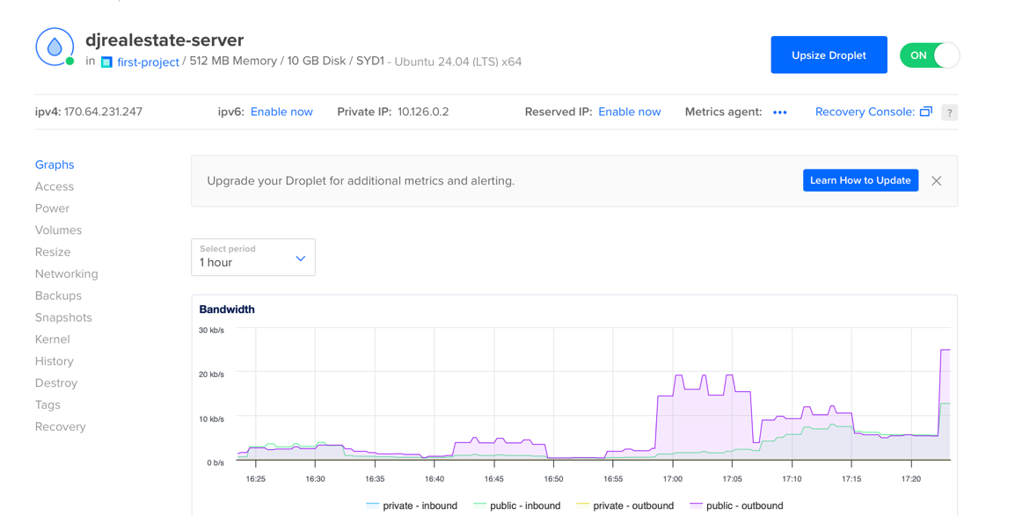

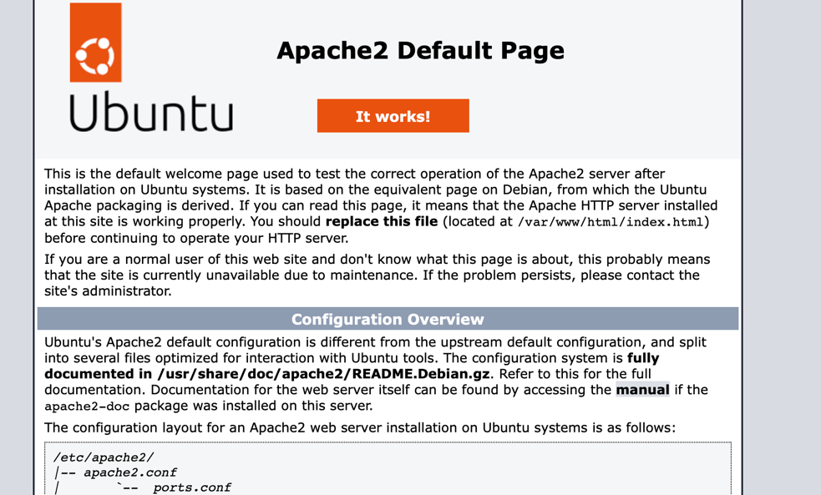

2. SSH Access (commands)

- bash

- ssh root@170.64.231.247

3. Update & Install Packages (commands)

- bash

- apt update && apt upgrade -y

- apt install apache2 mysql-server php libapache2-mod-php php-mysql unzip wget -y

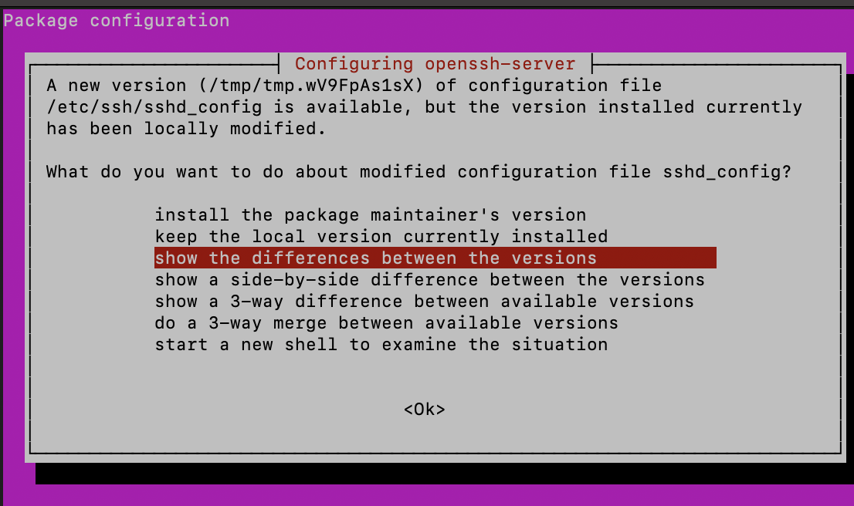

4. Start Services (commands)

- bash

- systemctl start apache2

- systemctl enable apache2

5. Configure Firewall (commands)

- bash

- ufw allow 'Apache'

- ufw allow OpenSSH

- ufw enable

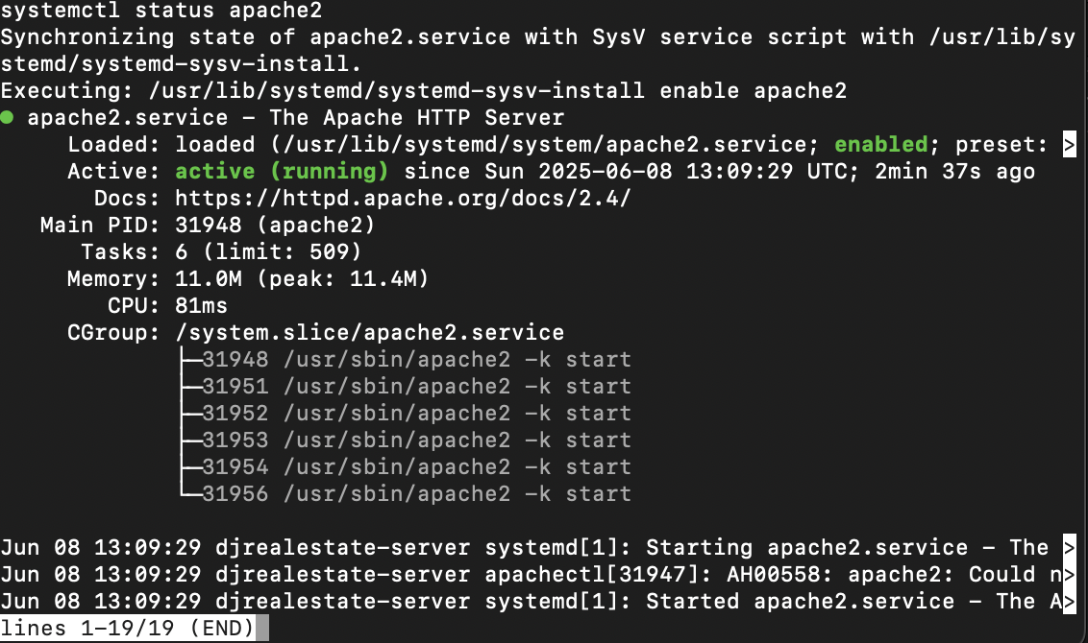

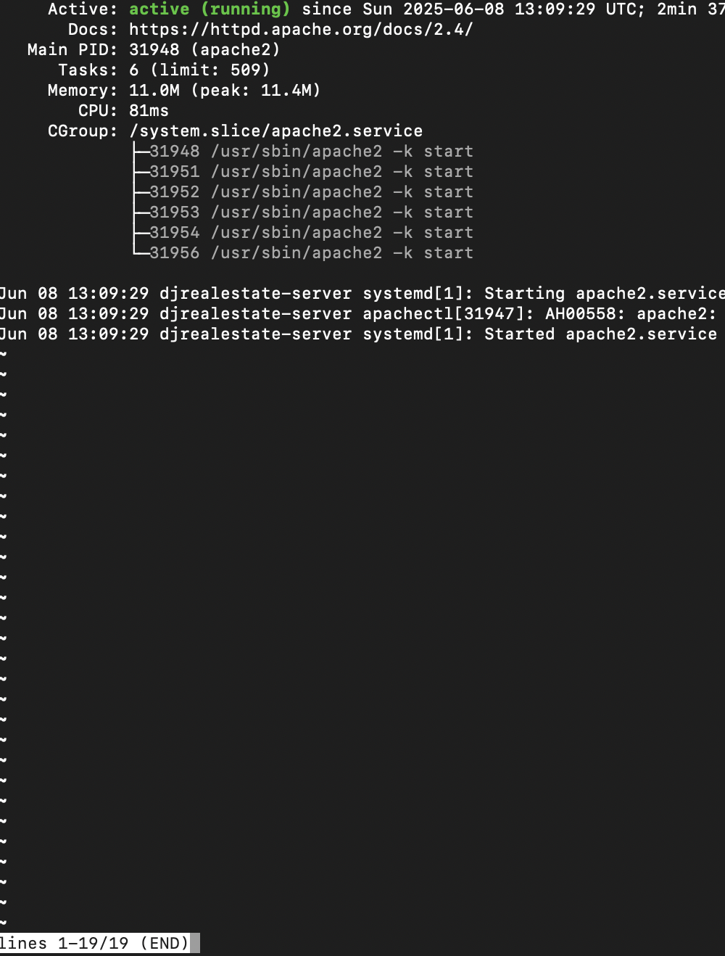

**MySQL Configuration** (commands)

- bash

- mysql

- sql

- CREATE DATABASE wpdb;

- CREATE USER 'wpuser'@'localhost' IDENTIFIED BY 'StrongPass123!';

- GRANT ALL PRIVILEGES ON wpdb.* TO 'wpuser'@'localhost';

- FLUSH PRIVILEGES;

- EXIT;

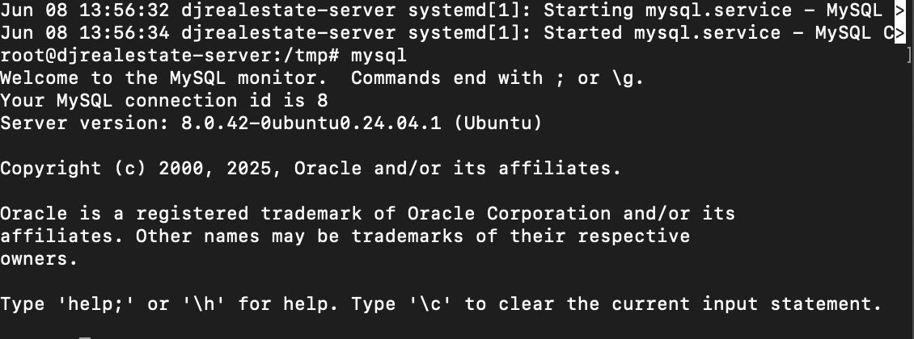

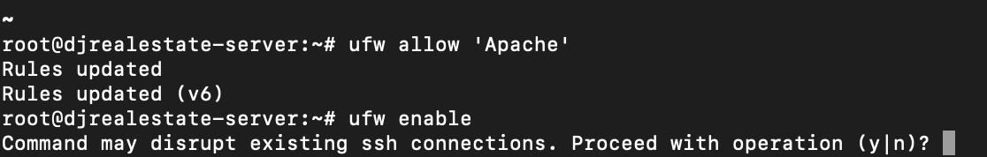

6. Install WordPress (commands)

- bash

- cd /tmp

- wget https://wordpress.org/latest.tar.gz

- tar -xvzf latest.tar.gz

- rsync -av wordpress/ /var/www/html/

- chown -R www-data:www-data /var/www/html/

- chmod -R 755 /var/www/html/

- rm /var/www/html/index.html

**WordPress Setup**

🡪 Visit: http://djrealestate.online

🡪 Setup Wizard: Language, DB credentials, site title, admin user

🡪 Admin Panel: <http://djrealestate.online/wp-admin>

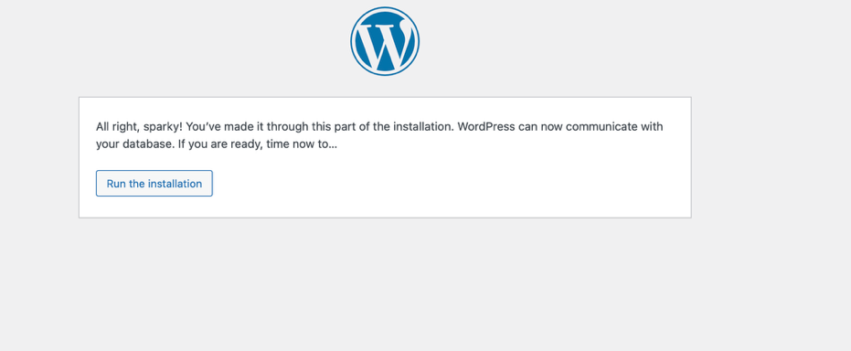

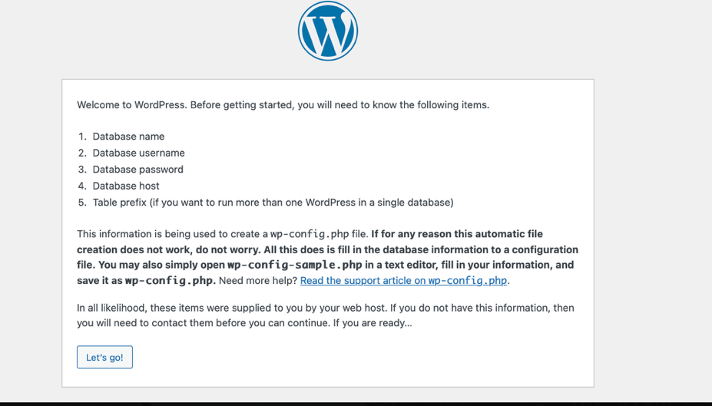  
  
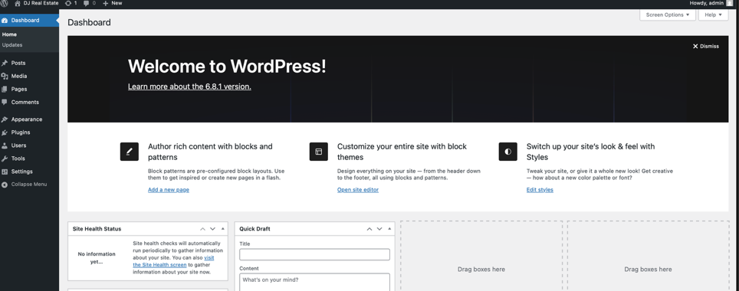

**Domain Name Configuration**

- Domain Provider: namecheap.com

- 1st of all I bought a matching domain name for my web page topic

- then I link my ip address of what gave me on digital ocean

- log in to my portal in namecheap

- click advance DNS

- click add new record

- DNS A Record:

- Host: @

- Type: A

- value : 170.64.231.247

- And again another add new record

- Host: www

- Type: A record

- value : 170.64.231.247

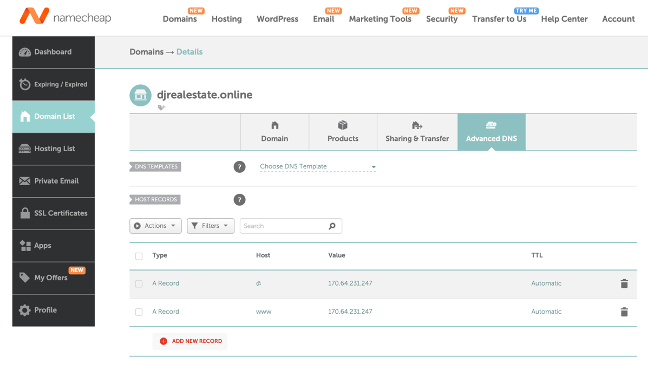

**🡪 SSL/TLS Certificate Installation**

* Update the Server and Install Certbot

sudo apt update

sudo apt install certbot python3-certbot-apache -y

* Run Certbot to Obtain the SSL Certificate

sudo certbot –apache

* When prompted, I selected both:

1: djrealestate.online

2: <https://djrealestate.online>

* Redirect HTTP to HTTPS

Please choose whether or not to redirect HTTP traffic to HTTPS:

1: No redirect

2: Redirect - Make all requests go to HTTPS

* Selected

Optione 2

* Result Verification

I opened both https://djrealestate.online and https://www.djrealestate.online in the browser.

Both showed a **🔒 secure padlock** in the address bar, confirming the SSL certificate is working.

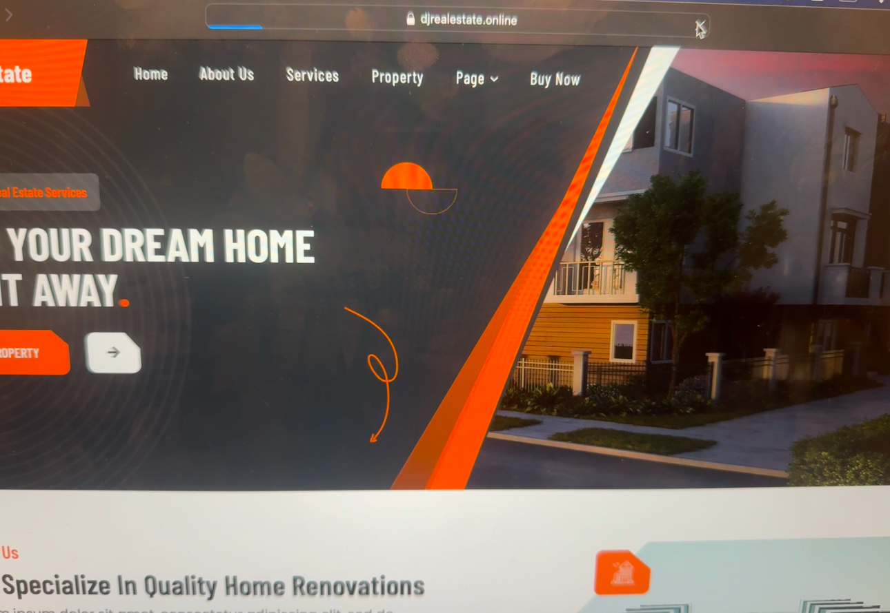

**Scripting Component**

**1. backup.sh – WordPress File Backup Script**

**Purpose:** Creates a compressed .tar.gz archive of the /var/www/html directory (WordPress files) for manual backup.

**Location:** /root/backup.sh

**Usage:** sudo /root/backup.sh

**Output:** /root/wp_backup_YYYY-MM-DD.tar.gz

#!/bin/bash

# WordPress backup script

BACKUP_FILE="/root/wp_backup_$(date +%F).tar.gz"

SOURCE_DIR="/var/www/html"

tar -czvf "$BACKUP_FILE" "$SOURCE_DIR"

echo "Backup completed: $BACKUP_FILE"

**2. update.sh – System Auto-Updater**

**Purpose:** Automatically updates and upgrades the server’s package list and security updates.

**Location:** /root/update.sh

**Usage:** sudo /root/update.sh

#!/bin/bash

# Automatically update and upgrade system packages

echo "Starting system update..."

apt update && apt upgrade -y

echo "System update completed on $(date)"

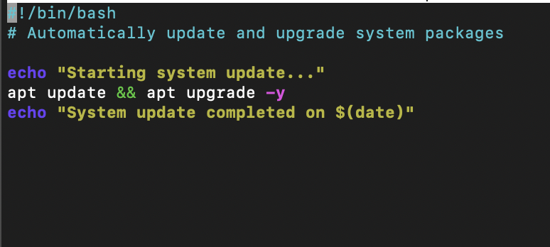

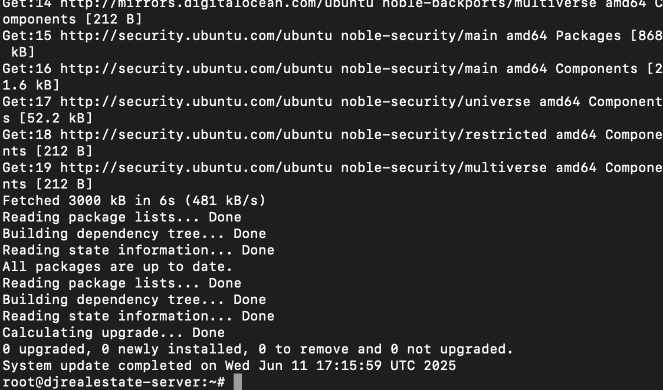

**3. check_ssl.sh – SSL Certificate Expiry Checker**

**Purpose:** Checks the expiry date of the SSL certificate for djrealestate.online.

**Location:** /root/check_ssl.sh

**Usage:** sudo /root/check_ssl.sh

#!/bin/bash

# Check SSL certificate expiry for your domain

DOMAIN="djrealestate.online"

echo "Checking SSL expiry for $DOMAIN..."

echo | openssl s_client -servername $DOMAIN -connect $DOMAIN:443 2>/dev/null \

| openssl x509 -noout -dates

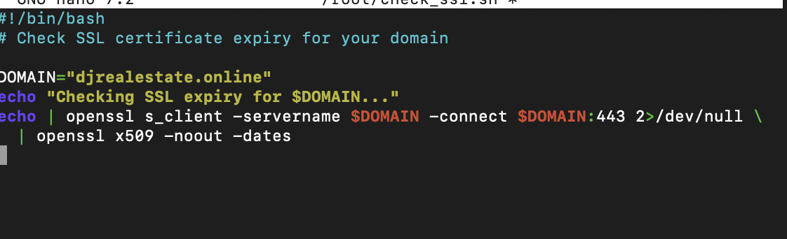

**4. db_backup.sh – WordPress MySQL Database Backup**

**Purpose:** Creates a .sql backup of the wpdb database into /root/db_backups/

**Location:** /root/db_backup.sh

**Usage:** sudo /root/db_backup.sh

**Output:** /root/db_backups/wpdb_YYYY-MM-DD.sql

#!/bin/bash

# Backup WordPress MySQL database

DB_USER="wpuser"

DB_PASS="StrongPass123!"

DB_NAME="wpdb"

BACKUP_PATH="/root/db_backups"

FILENAME="wpdb_$(date +%F).sql"

mkdir -p "$BACKUP_PATH"

mysqldump -u $DB_USER -p$DB_PASS $DB_NAME > "$BACKUP_PATH/$FILENAME"

echo "Database backup completed: $FILENAME"

5. db_backup.sh Script (MySQL Backup)

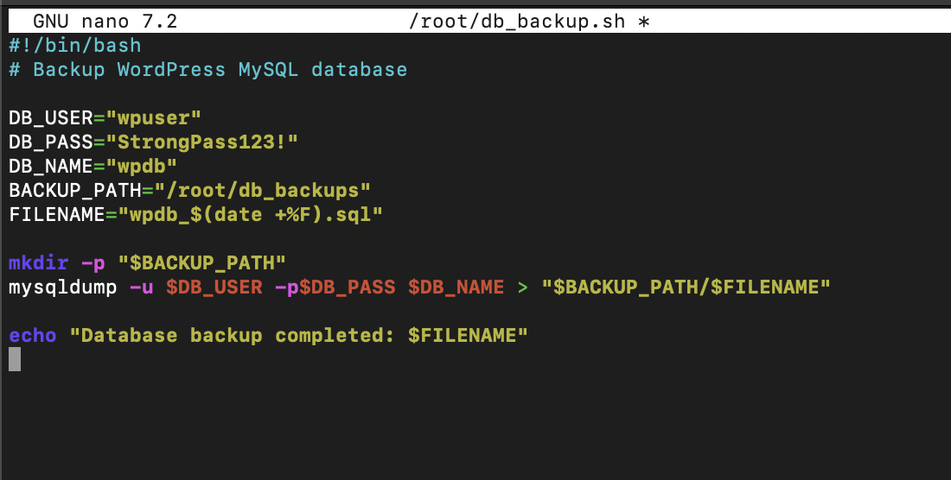

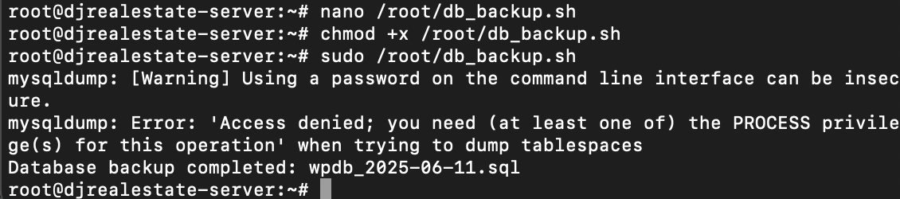



🡪 This is my GIT HUB account

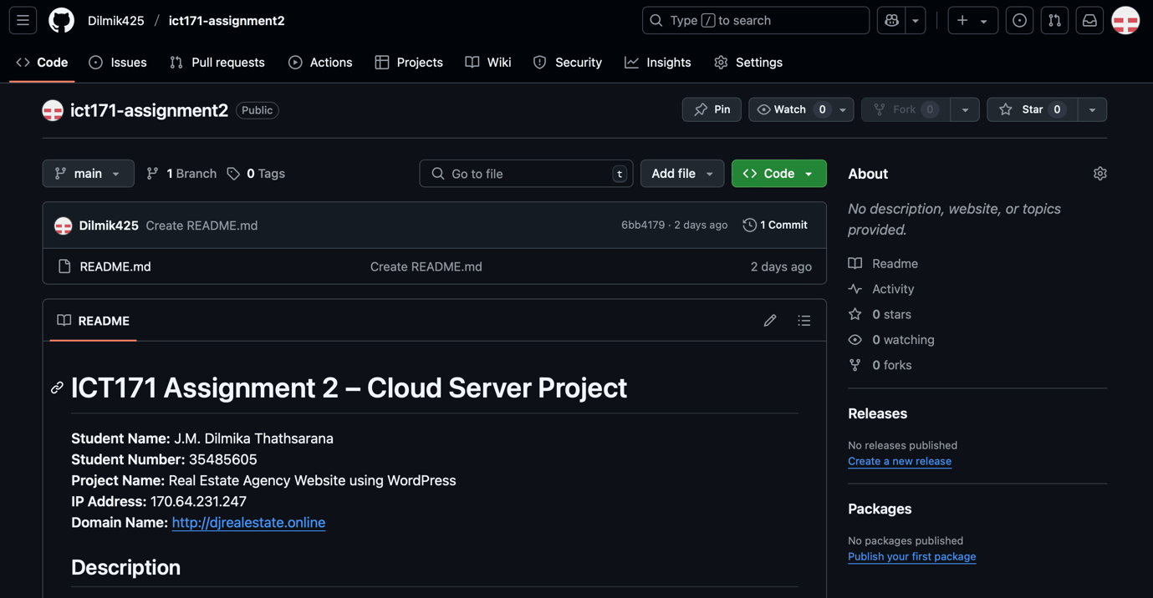

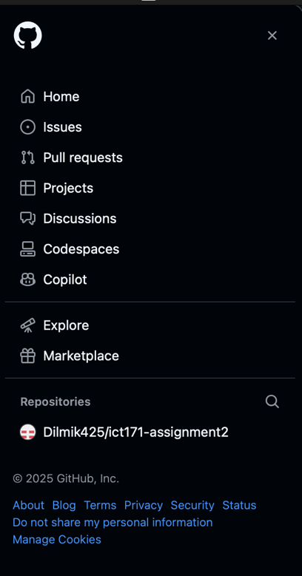

🡪 GitHub Repo & Video

- GitHub Repo: <https://github.com/Dilmik425/ict171-assignment2.git>

- Video Explainer: <https://drive.google.com/file/d/1dN7P-ok4lWqWkg4QUI5J5IHS8QxXpyfI/view?usp=share_link>

🡪Screenshots

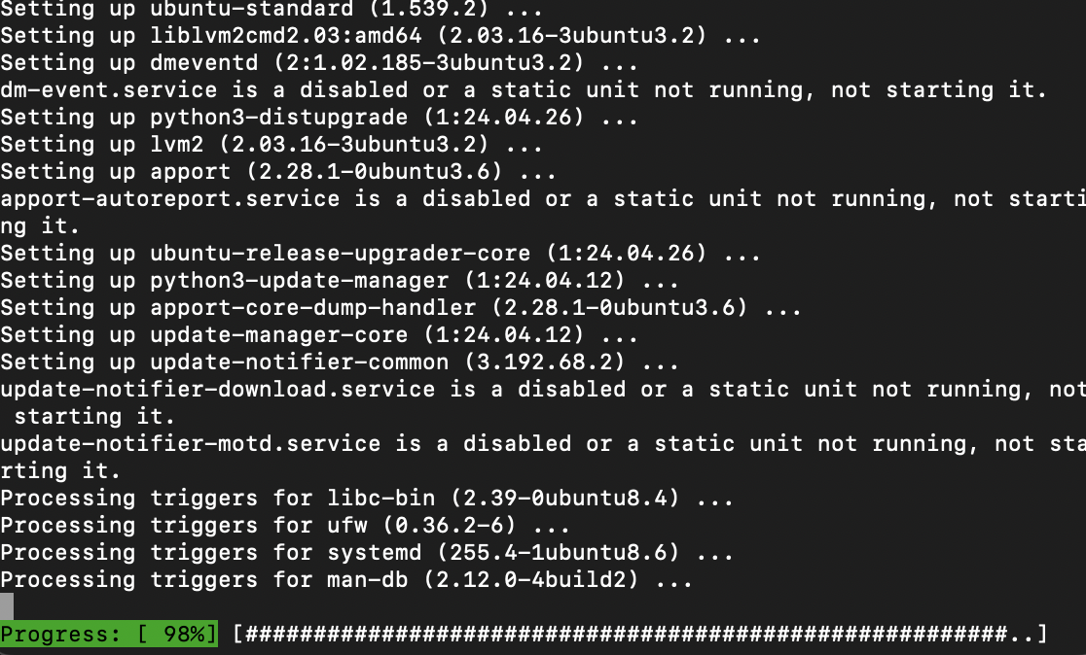

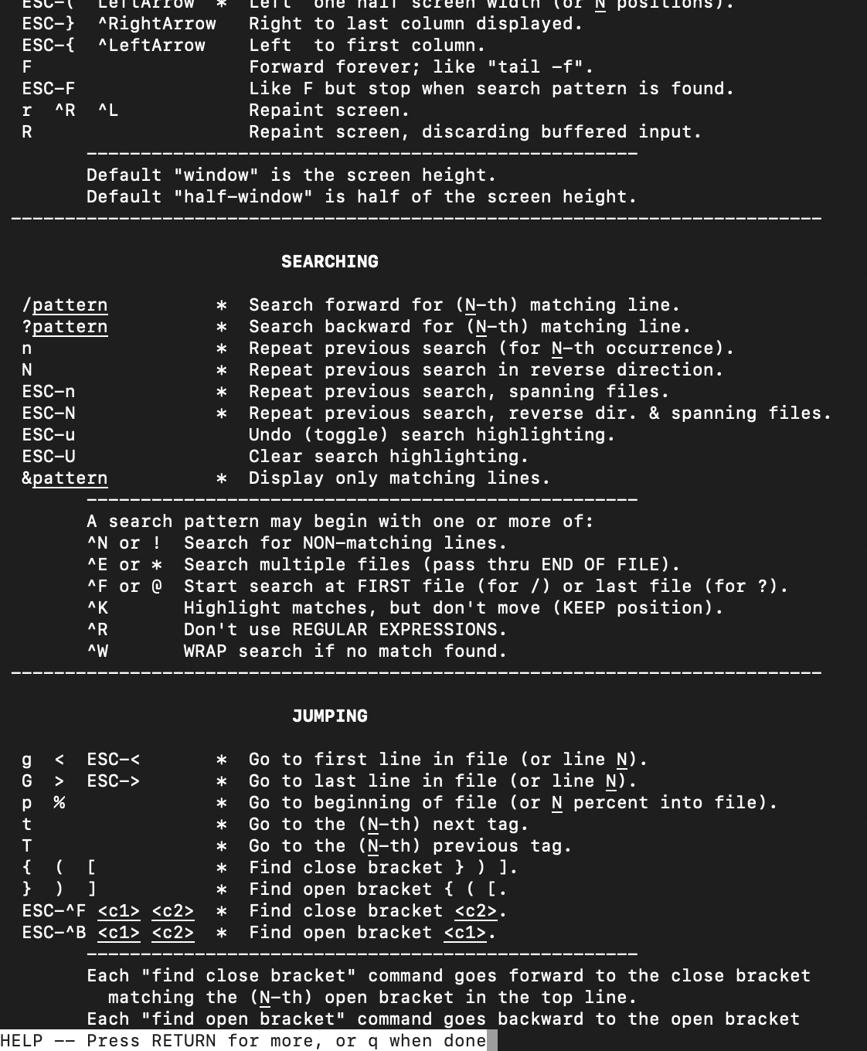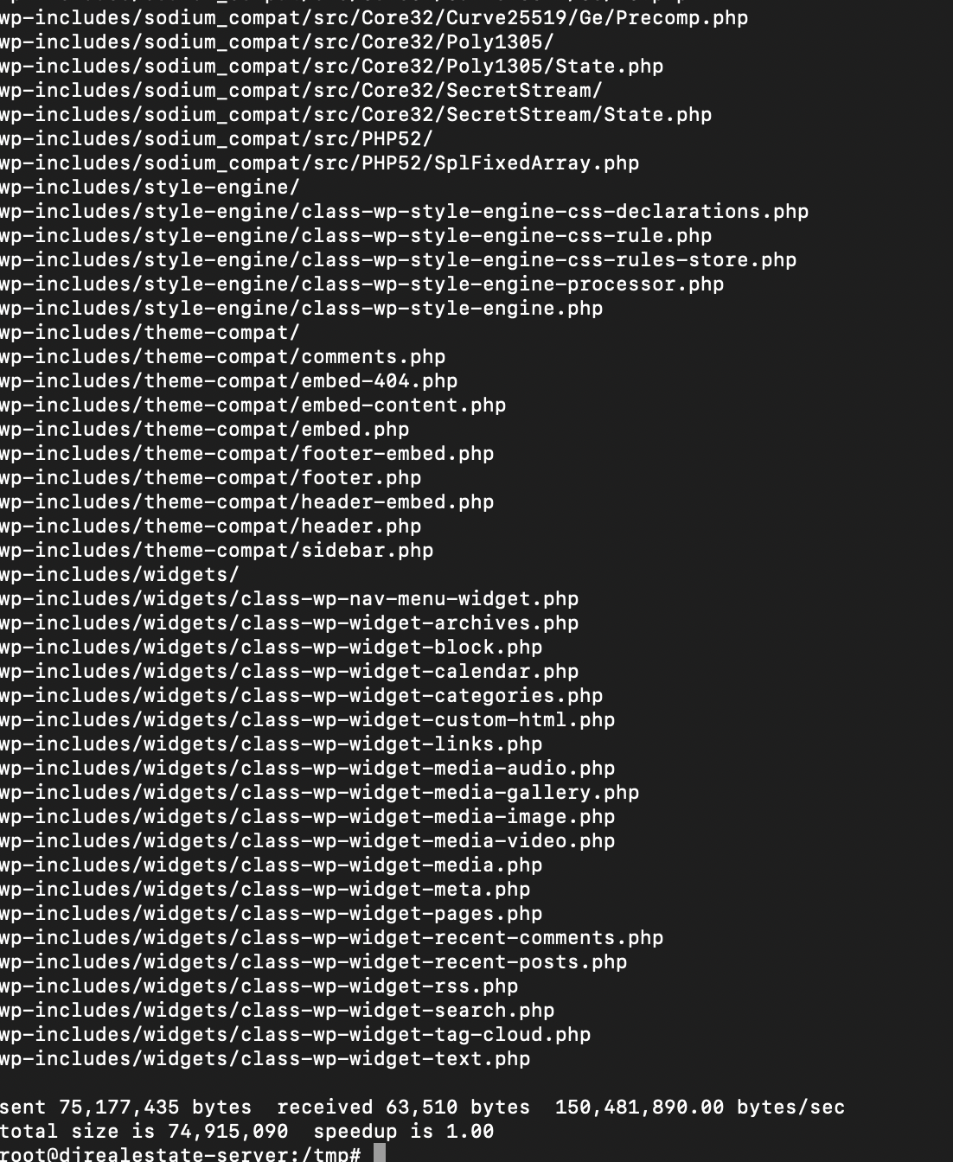

🡪 My wordpress admin portal

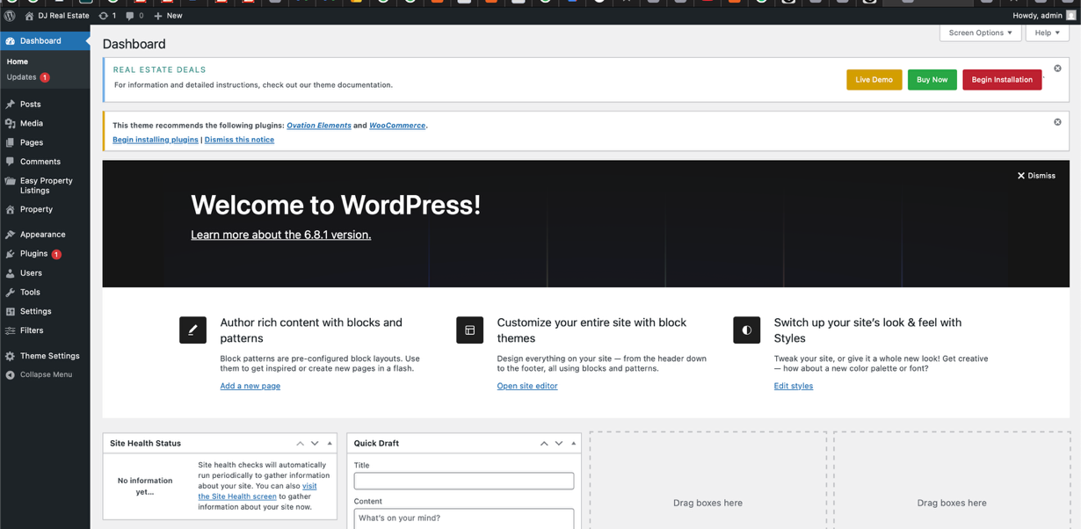

🡪 This is my web page.

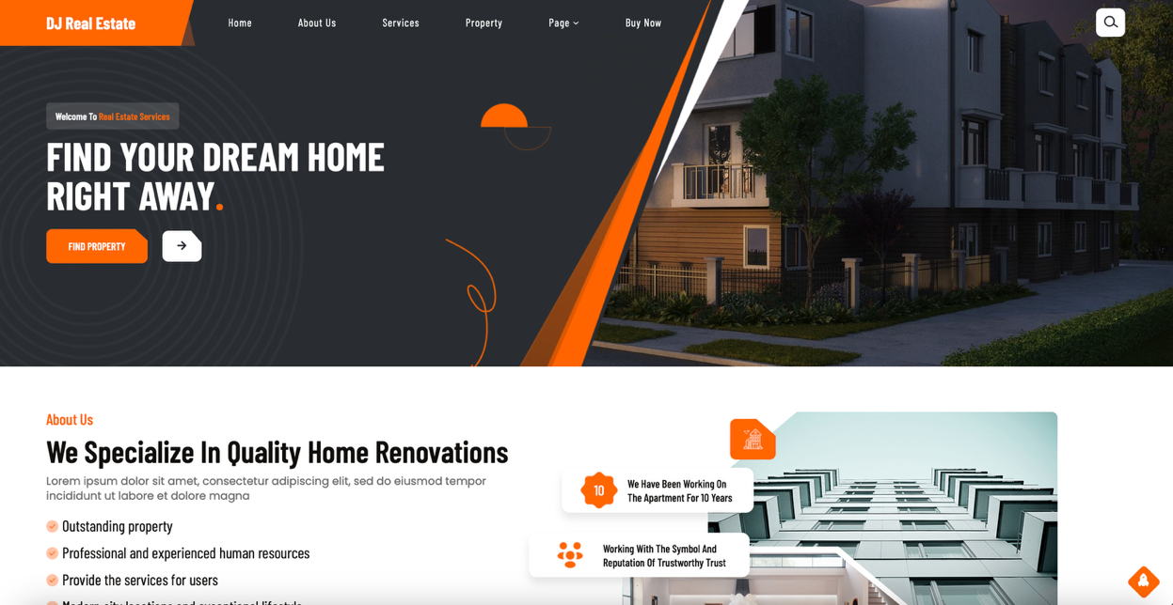

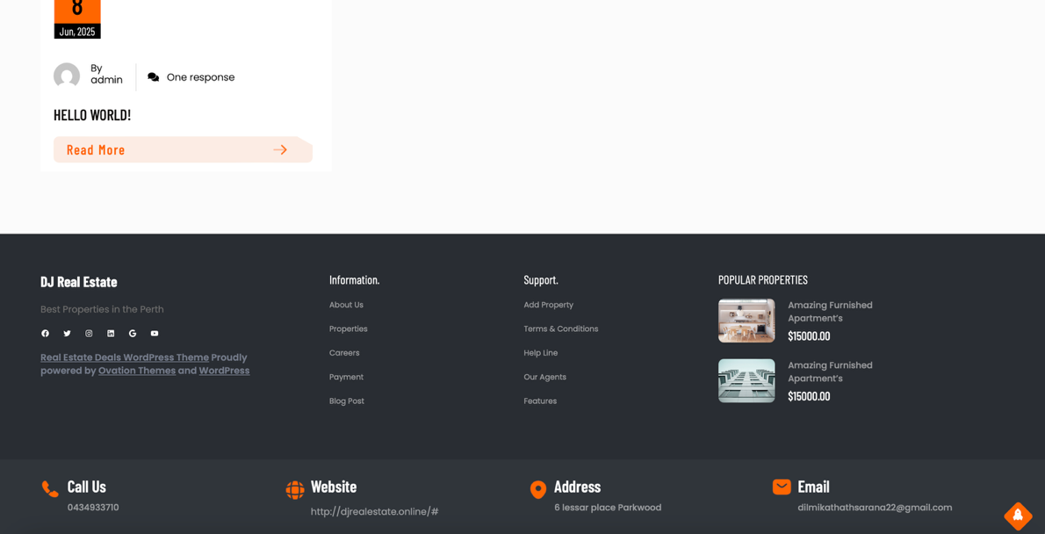

🡪 SSL Report

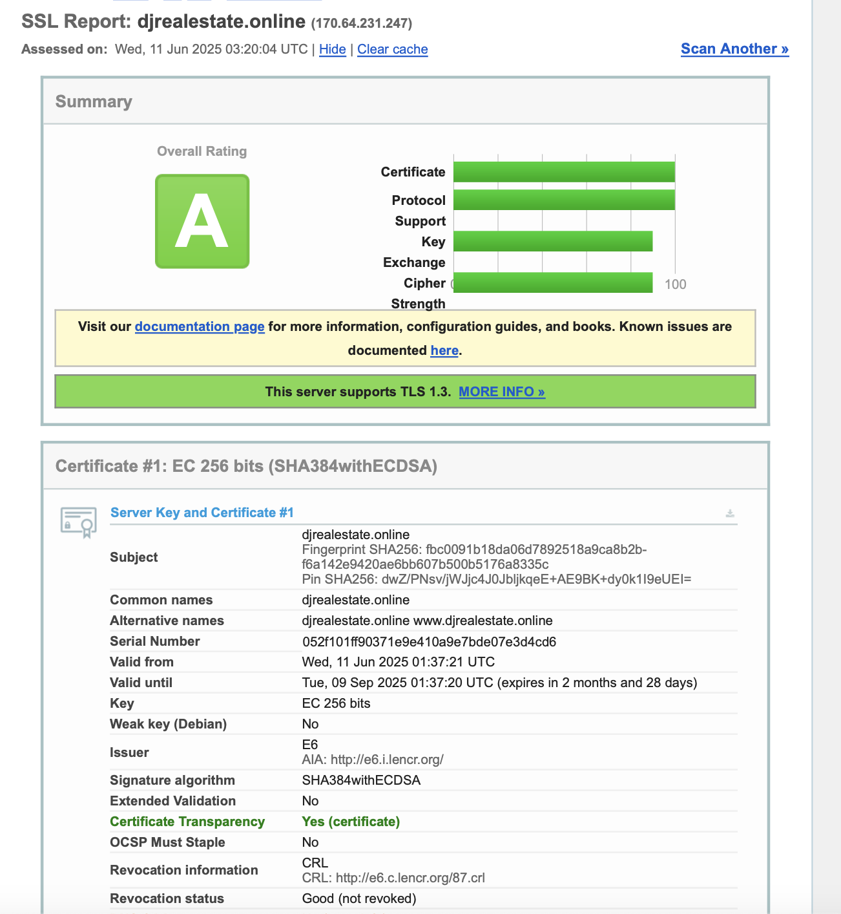

🡪 Reflection

* This project helped demonstrate practical skills in Linux server administration, manual application deployment, scripting, and using Infrastructure as a Service. I also gained experience linking domains and understanding firewall and backup automation.

References

DigitalOcean. (n.d.). Getting Started with Droplets. Retrieved from  
<https://docs.digitalocean.com/products/droplets/>

WordPress.org. (n.d.). Installing WordPress on Ubuntu. Retrieved from  
<https://wordpress.org/support/article/how-to-install-wordpress/>

Certbot. (n.d.). Enable HTTPS on Your Server with Certbot. Electronic Frontier Foundation. Retrieved from  
<https://certbot.eff.org/instructions>

Ubuntu. (2023). The Ubuntu Server Guide: Apache2, MySQL, and PHP Installation. Retrieved from  
<https://ubuntu.com/server/docs>

Namecheap. (n.d.). How to Set Up DNS Records for Your Domain. Retrieved from  
<https://www.namecheap.com/support/knowledgebase/article.aspx/9602/2237/how-to-set-up-dns-records-for-your-domain/>

GitHub Docs. (n.d.). Getting Started with GitHub Repositories. Retrieved from  
<https://docs.github.com/en/get-started/quickstart>

Linux Foundation. (n.d.). Introduction to Linux Command Line. Retrieved from  
<https://training.linuxfoundation.org/resources/free-courses/introduction-to-linux/>

OpenSSL. (n.d.). openssl - OpenSSL command line tool. Retrieved from  
<https://www.openssl.org/docs/man1.1.1/man1/openssl.html>